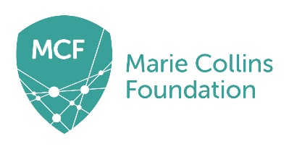 MARIE COLLINS FOUNDATION

PERSON SPECIFICATION –ADMINISTRATOR

Essential upon appointment | Desirable on appointment (if not attained, development may be provided for successful candidate)
Knowledge and Experience  - Knowledge of administration and office systems  - Experience of working with Microsoft Office and strong IT skills  - Experience of co-ordinating meetings and minute taking  - Experience of producing policies or procedural documents | - Knowledge of health & safety management and risk assessments  - Knowledge of statutory reporting for charities or charity governance  - Experience of website editing and management  - Experience of grant applications and bid writing
Occupational Skills
- Good interpersonal and communication skills
- Good numeracy and literacy skills
- Ability to work under pressure and meet deadlines

Qualifications
- Education to A-level or equivalent occupational experience | - First aid training
Personal Qualities
- Confidentiality and discretion
- High level of individual accountability
- Attention to detail and accuracy
- Organisational skills
- Ability to work successfully in a small team
- A positive and flexible attitude to work
Other Requirements
- To be committed to MCF’s policy and ethos.
- To be committed to Continual Professional Development.
- Motivation to work on behalf of children, young people and their families.
- Enhanced DBS clearance required
Equal Opportunities
- To assist in ensuring that MCF’s equalities policies are considered within the Charity’s working practices in terms of both employment and service delivery.

